
School Of Engineering Technology and Applied Science (SETAS)
Advanced Manufacturing and Automation Technology (AMAT)

Automation and Robotics Technology

ROBO356- Design and Development Project 1
Section: 009 (Group 2)
Project Name: Remote Control Car
Title of Submission: Final Report
Date: 13.12.2020

Professors: Alaeddin Bani Milhim
Florin Bratu

Submitted By:
Yaroslav Ishutko (301004764)
Vladislav Marchenko (301005635)

Declaration of Authorship (By Group 2)

We, Yaroslav Ishutko and Vladislav Marchenko, confirm that this breakdown of authorship represents our contribution to the work submitted for assessment and our contribution is our own work and is expressed in our own words. Any uses made within the Technology Report of the works of any other author, separate to the work group, in any form (ideas, equations, figures, texts, tables, programs), are properly acknowledged at the point of use. A list of the references used is included.

Final Project Report Contribution Table
Section: | Person responsible:
Title Page | Yaroslav Ishutko
Declaration of Authorship | Yaroslav Ishutko
Abstract | Yaroslav Ishutko
Table of Contents | Yaroslav Ishutko
List of Illustrations | Yaroslav Ishutko, Vladislav Marchenko
Introduction | Vladislav Marchenko
Mechanical Design | Vladislav Marchenko
Electrical Design/Software | Yaroslav Ishutko
Troubleshooting activities | Yaroslav Ishutko
Data Analysis | Vladislav Marchenko
Conclusion | Vladislav Marchenko
Recommendations | Yaroslav Ishutko
Bibliography | Yaroslav Ishutko, Vladislav Marchenko
List of Acronyms | Vladislav Marchenko
Glossary of Terms | Vladislav Marchenko
Appendices | Yaroslav Ishutko, Vladislav Marchenko

Abstract
Remote Control Car project was conducted by Group 2 on ROBO 356 section 009 to successfully design, build, troubleshoot and operate a remotely controlled vehicle. Project was initially planned on 13 weeks (later shorten to 11 weeks). Due to personal effectiveness of all members of Group 002 and excellent group schedule it was possible to reach all main goals (and present the result to faculty) be the week 11. Thus, RC Car was successfully designed and constructed regarding and referring to initial technical requirements and, as a result, not only fully satisfies it, but also possesses several unique features that significantly increase its efficiency and are the subject to be discussed further in Final Report. Final Report on RC Car reflects all the technical requirements of the project (RC car should be capable of riding, steering, climbing the ramp, transporting light objects, etc..), rationale for the methods used, methodology (design principles, components and actuators used and their justification), bibliography (scientific references that had influence and shaped an initial idea of the project), design and troubleshooting activities during 11 weeks of project research and construction, resulting data analysis ( comparing of calculated theoretical and actual test data regarding RC Car performance) and overall project conclusions. Besides, some recommendations on further design project_1 course development are included as well as all the references, acronyms, terms are presented and listed in corresponding sections after the main part of the report. Finally, all technical data, formula references, final RC Car software code as well as both mechanical and electrical design figures are presented in acronyms.

Table of Contents

- Cover Page 1
- Declaration of Authorship 2
- Abstract 3
- List of Illustrations 5
  - List of Figures 5
  - List of Tables 5
- Introduction 6
- RC Car Design 7
  - Mechanical Design 7
  - Electrical Design/Software 9
  - Troubleshooting Activities 11
    - Gripper installation 11
    - DC Motors selection and adjustment 12
    - Front wheels installation 13
- Data Analysis 14
- Conclusion 15
- Recommendations 16
- Bibliography 17
- List of Acronyms 18
- Glossary of Terms 19
- Appendices 20
  - Appendices A 20
  - Appendices B 24
  - Appendices C 25
  - Appendices D 27
  - Appendices E 29
  - Appendices F 31

List of Illustrations

List of Figures
- Standard Hitec Servo Motor dimensions 11
- Stainless Steel Pan Head Phillips Screw 12
- Wheel Axial Locating using Spring Pins (schematics) 13

List of Tables

- Project Contribution Table 2
- I/O table 9
- Data Table 14

Introduction
The goal of the project is to design a vehicle that will be capable of moving forward, backward, overcoming the inclined ramp , as well as to steer, grip the coffee cup and deliver it to the designated location. The car must be operated remotely and should be able to complete the task in 4 min. The cup must not touch the floor while being gripped.
The design has some limitations that should be considered while designing the vehicle.
List of limitations include such parameters:
- Vehicle should be safe to competitors
- Overall vehicle dimensions must not exceed 10 by 16 inches and be able to be carried by one person
- Vehicle wheels must be in a range of 2 to 6 in in diameter
- The only power supply that could be used is 12V Battery
- To propel the vehicle only to specific 12V DC motors were given
- No wood, toy components, glue , tape breadboard, are allowed
- Vehicle must be self-contained

The design objective was to satisfy all the criteria mentioned above. To achieve the assigned configuration, the simplified physical- mathematical model was used to design the car for the scratch.
First of all it was decided that the vehicle will run on 4 wheels , 2 of which will be directly connected to the shafts of the 12 V DC motors. The other 2 wheel will be used in the steering mechanism. As a control will be used an app on the phone
Secondly, the design was based on the provided materials and parts. For example, the DC motors were meant to be attached to the base via L- bracket of specified shape. The base was supposed to be made of 10 by 16 inch aluminum plate and be able to old the battery an the rest of the components on it. Taking into consideration all the parameters it was decided to design from scratch the unique steering system with shafts, which will be connected to the wheels, and will be operated with help of servo motor to rotate left and right.
Thirdly, to satisfy the goal of the project additional components were obtained. These include: gripper operated by servo motor to grip the cup, Arduino UNO microcontroller as main logic element, Bluetooth module compatible with Arduino to connect to the phone app, Motor drive shield for Arduino to control 2 DC motors, Ultrasonic sensors to measure distance to objects, power switch and fuse for system safety and to avoid shortage in the wiring, LEDs and resistors for indication motion forward, backward or obstacle.

RC Car Design
Mechanical Design
The primary idea of mechanical design was to estimate the required base plate dimensions to fit the necessary components : L – brackets, DC motors, steering Mechanism, Battery, Arduino UNO, Bluetooth module, Motor shield, gripper and Ultrasonic sensor. By using the 3D Engineering software Inventor, all parts were drawn accurately to their real- life dimension and placed on the base plate. The estimated length was determined as 12 in. The length for Full steering system including Servo motor, and Steering mechanism was estimated in 5 inch length. By placing the 2 DC motors on the plate opposite to each other it was determined that the required width of the project will no exceed 7 inches.
The mechanical design had to satisfy 3 main features:
- Motion Forward/Backward
- Steering
- Gripping the cup
For motion the Forward/Backward the 2 DC motors were used at the rear, in other words the vehicle was designed to have rear drive. DC motors were connected to the L brackets which itself were connected to the base plate at the rear . All connection were done by Hex cup bolts.
For Steering purpose the Steering Mechanism was designed because it has an advantage of more precise control.
While designing the steering mechanism few criteria were followed such as
- The dimensions of the steering should not exceed 7 by 5 inch;
- Shaft for the steering should be on the same level as shaft of the DC motor to avoid the base plate inclination.
- Steering have to be attached to the base plate mechanically
By considering all of the above it was decided to design 2 Angle blocks of the L- Shape with shafts that will be connected to the base via bolts. From the beneath Angle blocks will be supported by the plate and from top by the base plate itself. To make sure that the Angle blocks steer to the same angle they were both attached to each other by the Steering Angle which will be connected to the servo later. By implying such construction the Angle blocks were lined up and were steering at the same angle when the Steering angle was rotated.
For Gripping the cup, the prototype of the Gripper was ordered and was modified.
The modification of gripper included facing off the unnecessary material from it claws and making the certain bolted connection to the servo motor and later to the plate itself.
After all main components were attached to the base plate, the central of mass was found and the rest of the components were placed to achieve equal weight load of rear drive and the steering mechanism. For such arrangement the heaviest component 12 V battery was placed between these two points.
All of the components were attached to the base plate by bolts except for the LEDs.
They were fitted in a specific bracket and then the bracket was tightly fitted to the base plate holes for the LEDs.
Two LEDs are present at the front and at the rear side for indication of Forward and Backward motion respectively.
The ultrasonic sensor was mounted at the front on holding bracket first and then attached to a 7 inch long holding panel that was attached to the base plate.
The Gripper which consists of Gripper and servo motor was decided to mount at the rear.
The battery was placed between Gripper and Arduino UNO, motor shield was placed at the top of the Arduino microcontroller as well as the Bluetooth module. Servo motor for the steering was placed between Arduino and ultrasonic sensor.
The secured mounting of battery and steering servo were achieved using holding plates tightened to the base plate by bolts foe each of them.
Switch and Fuse were placed closely to battery to avoid long wiring.
For more information regarding Mechanical Design please refer to the A

Electrical Design/Software
To begin with, it is necessary to point out that Electrical Design as well as Software are usually much more flexible in terms of troubleshooting. This is due the fact that all electrical or electronic components and programming space are heavily standardized and are available in already built-in universal packages/platforms for a moderate price. At our particular project of constructing Remotely Controlled Car we have also decided to use already developed and manufactured well-known universal electronic devices and available (easily accessible) user-friendly software to control mechanical actuators and signaling devices.
The key component or, in other words, the “brain” of our system became an Arduino Microcontroller integrated in universal Arduino Microcontroller Platform – Arduino Uno. This device is very flexible, customizable and has decent computing power that fully satisfies system requirements and an amount of data to be operated during normal performance. When choosing Arduino Uno platform it was ensured that there is enough Input/Output points for the number of operating device to be interfaced with Arduino. The list of used electronic devices is: Servo Motor1 (steering function), Servo Motor2 (gripping function), Ultrasonic Sensor (sensing distance and avoiding collisions), Bluetooth Module (serial communication between operator and RC Car), 2 x DC motors (prime movers) and 3 x signal LED’s (Forward, Reverse motion and Amber collision light). During the process of designing the electrical signal schematics for the system, 14 digital I/O pins of Arduino UNO were assigned to different devices as follows:
Input/Output Table
Arduino Platform-to-Pololu Motor Shield (interconnected pins)
Motor Direction Input A | Pin D2
Motor Direction Input B | Pin D4
Motor Enable Input | Pin D6 (Pwm)
Motor Speed Input | Pin D9 (Pwm)
Pololu Motor Shield-to-field devices (wire connections)
Forward LED Output | Pin D10
Reverse LED Output | Pin D11
Amber LED Output | Pin D12
Servo 1 Signal/Pulse Output | Pin D3
Servo 2 Signal/Pulse Output | Pin D5
Ultrasonic Sensor Trigger Output | Pin D7
Ultrasonic Sensor Echo Input | Pin D8
TX to Bluetooth RX Output | TX/Pin D1
RX from Bluetooth TX Input | RX/Pin D0
Power Connections of Pololu Motor Shield
Battery (main power supply) 12V | VIN wire terminal
Battery (main power supply) GND | GND wire terminal
2x DC Motor “+” | M1A wire terminal
2x DC Motor “-“ | M1B wire terminal
Power Connections of Arduino Platform
Battery (main power supply) | Power port (by multi-purpose power cable)

Note that Arduino UNO Microcontroller Platform was fully interfaced (100% compatible) with Pololu Motor Shield (Motor Driver), meaning that each pin of Arduino was interconnected with corresponding pin of Pololu platform and, as a result, pins were shared. Pololu Motor Shield was used as a special high-power interface for low-power Arduino controller (low currents, 5V outputs) and high-power 12V outer system.
Researching the “Pololu Simple Motor Controller User’s Guide” by Pololu, it was found out that pins D2 and D4 would control motor’s direction (terminals A1 and A2), pin D6 acts as a motor’s movement enabler and, finally, pin D9 (PWM~ pin) is a motor speed Input. It is important to mention that 2 DC motors were wired together (parallel) to a single motor terminal. It saved 4 extra pins on Arduino/Motor Shield and ensured that both motors receive exactly same commands during operation, as needed.
Both, steering Servo and gripping Servo (Hitec servo motors were used) required 5V and GND (was taken from 5V output on Pololu Motor Driver) and a controlling signal from one of 14 digital pins. It was important for correct operation that the pins for both servo motors are “PVM” Output pins (~ sign). It was needed for proper control by applying a series of high-frequency pulse signals. Thus, pins D3 and D5 were chosen.
According to the “The HC-05 Bluetooth Module with Arduino” article, Bluetooth module needed only 3.3 V power source that was also presented on Arduino Motherboard Platform. Practically, it was proved that 3.3V is enough for uninterrupted operation. Thus, Bluetooth module had a separate reliable power supply. Pins for serial communications (Rx and Tx) were set as D1 and D0 respectively. Servo Motors were easy to control using special Arduino code library represented in Appendices: C.
Ultrasonic Sensor (HC-SR04) required signal pins to be configured as digital Input and Output. Pins D8 and D7 were chosen respectively and, later, configured. Sensor uses Arduino Timer Module to measure the distance having the speed of ultrasonic waves as known value. It measures time between sending and receiving reflected signal and, using, timing and program calculations, user is able to determine exact position. Sensor was powered by stable 5V Output.
3 signal LED’s received pins at last order, as there were absolutely no special requirements for them. Pins D10, D11 and D12 were assigned to 2 Forward, 2 Reverse and 1 Amber light. 330 resistor was wired between Output pin and each LED to ensure proper voltage drop (1.8V) on LED (5V Output pins) for their correct operation. All leads were isolated, so no shortage could occur.
For common sense safety purposes, 2 A fuse and Main Power Switch were installed between Main Power Source (12V Battery) and the rest of the system.
To learn more about electrical system design for RC Car – refer to Appendices B.

Troubleshooting activities
Gripper installation
Considering the fact that RC Car had to climb a steep ramp (~23*) it was decided that the gripper has to be mounted at a certain elevation as for the level of the car base plate. After standard Actobotics Gripper (Kit B) was found and chosen for our project due to its compatibility with a series of standard servo motors, its was decided to secure gripper on the top of the servo motor, while using bolts, secure them both to the base plate. This method satisfied our initial requirements, was easy to implement and was anticipated by servo motor and gripper mechanical structure. The only problem seemed in the availability of thin (to fit special mounting holes on gripper’s sides), but very long (gripper height together with servo motor height resulted in around 1.65” length) and rigid bolts. As Centennial College Inventory couldn’t satisfy our need, we (Group #002) conducted our independent research and found bolts of satisfactory size (6-32 Thread, 2-1/2" Long bolt). Set of 2 bolts, 2 nuts and 2 washers was acquired and used for successful and safe installation of gripper.

Figure 1, Standard Hitec Servo Motor dimensions

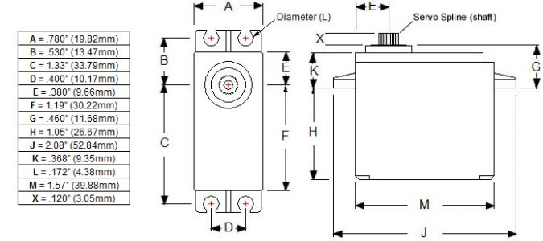

Note* Original image is reprinted from DFRobot , Hitec HS422 Servo.
Retrieved from: https://www.dfrobot.com/product-152.html

Figure 2, Stainless Steel Pan Head Phillips Screw
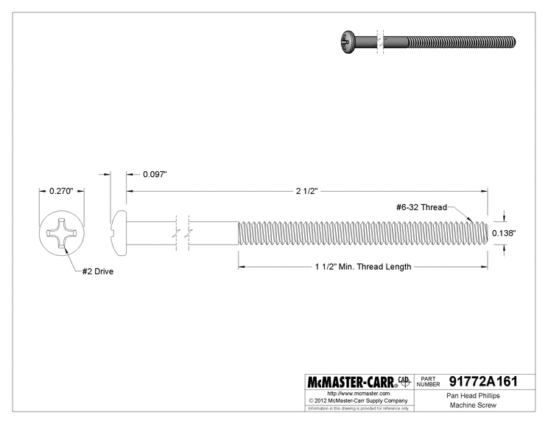
Note* Original image is reprinted from McMASTER-CARR, (2020), Passivated 18-8 Stainless Steel Pan Head Phillips Screw.
Retrieved from: https://www.mcmaster.com/91772A161/

DC Motors selection and adjustment
As per initial idea and construction design, steering was meant to be achieved by using separate front wheel transmission controlled by a servo motor. In this case, both 2 DC motors (prime movers) were connected to same output terminals, received same signals at the same time and had to rotate with exact same speed to achieve straight linear movement and precise control. 2 DC motors, acquired from Centennial College initially were proved to be asynchronous in terms of output speed, even though they both received voltage from the same source. To solve this problem, motors were exchanged on a pair with exact same characteristics (consumed current and voltage drop on motors was measured by multimeter: 108mA and 11.7V drop). Voltage drop, consumed current were repeatedly remeasured as motors were secured in L-shape brackets using multiple bolts. As a result – exact speed of both motors was achieved. Deviation of the car during normal performance was observed to be minimum (1-3* or 7-8 cm over 3 m distance).

Front wheels installation
Due to unique design of the car overall and of the steering structure in specific, there was a strict design requirement for both front wheels to spin or rotate freely on the shaft (press fitted into the rotating angle element of the steering system) while being reliably secured axially on the same shaft. To achieve this, it was decided to use tiny pins (pin – device commonly used to axially secure rotating elements on the shaft) from both sides of the each wheel – 4 pins in total. Holes were drilled on small and round shaft, so great precision was achieved using milling machine (up to 0.0001” precision). Wheels and corresponding pin holes for them were located on exact same distance from both sides to ensure precise steering. Holes’ diameter was only around 0.05”. Spring pin type was used – it expands while placed into the hole, thus preventing any slippage and unsecure fixation.

Figure 3, Wheel Axial Locating using Spring Pins (schematics)

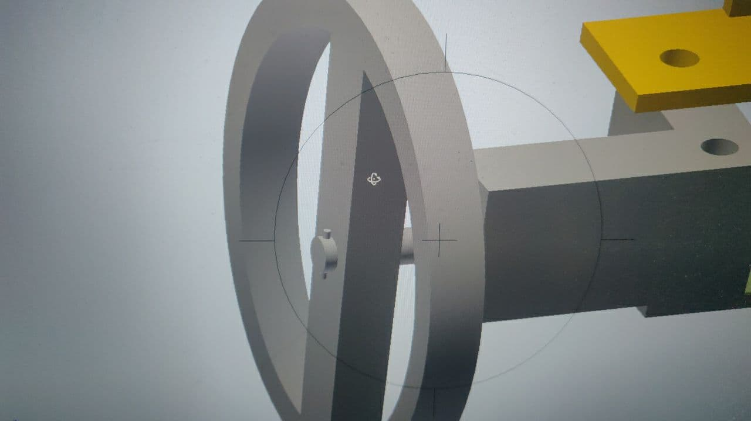

Note* Picture is taken from RC Car mechanical drawing/schematics - Appendices A

Data Analysis
Based on the acquired material and components it became possible to compute the maximum speed, torque, friction with surface and gripper holding force.
Motor Speed | 160 RPM
Wheels diameter | 45 mm
Wheels Circumference | 0,2673 m
Max Speed | 0,71m/s
Weight | 2,5 kg
Motors Toque (Total) | 39,24 N*cm
F required | 25,39 N
F acquired | 34,8 N
Steering motor Torque | 4 kg*cm
Steering Motor Force | 1 kg
Force to hold cup | 0,25 N
Torque achieved at the gripper | 40,21 N*cm
Safety factor for Gripper | 22

However in reality it was found out that the car achieve a slightly higher speed than was calculated , as well as the Actual torque produced by the motors appeared to be higher will allowed the car to climb even more inclined ramp than 23 degrees.
For the actual speed it was measured to achieve of 0,83 m/s while measuring time to reach 2,5 m for time of 3 s.
Construction of the steering mechanism was estimated to add additional 0,7 kg to total weight of the car and based on that number the servo motor required torque for steering was calculated .
The design was mostly symmetric, combined with synchronous rotating motors it allowed to achieve a straight motion on the test.
Due to firm connection to the base with the bolts, the vibration occurred during test was insignificant and therefore making the vehicle able to sustain self-contained for a long time.
The use of servo motor made it possible to achieve precise steering even during the maximum speed.

Conclusion
In conclusion, the designed vehicle managed to complete all the tasks and objectives that were set, furthermore the outcome of the project was more satisfactory than expected in terms of vehicle technical characteristics: the speed achieved was higher than anticipated , so was the ability of overcoming more inclined ramps and carrying more heavy objects. The straight motion became possible due to symmetric design and precise steering control. Overall, the method of applying physical-mathematical model, combined with designing the vehicle in the CAD engineering software was effective. The further design improvements are possible in achieving higher speed and acceleration by adding gear box to the rear drive and improving the steering system by adding additional motors to the front drive, thus making car full drive, or replacing motors with more powerful analogs.

Recommendations

Overall, Design and Development Project_1 course possesses satisfactory academic quality is intensive and has both theoretical and practical activities to be completed during the semester.
On the other hand, there certainly is a room for further development and improvements.
We introduced several possible improvements that, in our opinion, could contribute to the course in future:
- Theoretical background
From the practical experience of many students, 2 previous semesters of studying do not provide sufficient academic background and specific applicable knowledge that could help during comprehensive RC Car design and construction. We suggest to implement concepts of automation and automotive systems design, automotive motion and power transmissions and physics/calculations for power transmissions/drives as a part of some engineering courses prior to Design and Development Project_1. It also refers to the study of microcontrollers and C# programming – having both courses in same semester, students are not able to spend time effectively, as, most of the time, they do not possess enough knowledge to program car yet.

- Project Evaluation
We find it right to evaluate final outcome of student project. However, we suggest to evaluate design component rather than performance. First of all, the objective of the course is to learn, investigate and create. You should support unique decisions, “thinking out of the box” and creativity, rather than immediate effectiveness in particular situation. Especially, when every group has exact same power source and prime movers. In the end of the day it comes to: minor factors (that are even hard to account) and simple luck. Also, each project/design should be evaluated independently, as the last team in the strongest section may still be better than the best team in weakest section, yet, having totally different grades for the same performance.

- Inventory and Tools
Even though most of the machinery in College Machine Shop may be old, it still functions well. The only suggestion as for heavy equipment and machinery would be to acquire a number of equipment with higher precision for delicate/high-precision material processing. However, there is totally different situation with availability of various hand tools, minor details and raw material. It would be much better if student had access (while constructing a complex system) to a various materials (metal sheets, plastic, insulators, tubes) – not only occasional leftovers. Also, often used tools (end mills, chucks for milling, calipers, etc) are usually in poor condition and have to be replaced. Overall expansion of inventory volume and diversity would definitely contribute to the course quality and student performance.

Bibliography
DFRobot , Hitec HS422 Servo.
Retrieved from: https://www.dfrobot.com/product-152.html

Makersspaces.com, Arduino For Beginners.
Retrieved from: https://www.makerspaces.com/arduino-uno-tutorial-beginners/

McMASTER-CARR, (2020), Passivated 18-8 Stainless Steel Pan Head Phillips Screw.
Retrieved from: https://www.mcmaster.com/91772A161/

Pololu, (2020), Pololu Simple Motor Controller User’s Guide.
Retrieved from: https://www.pololu.com/docs/0J44

Sanjay Rajure (2019, May18), The HC-05 Bluetooth Module with Arduino.
Retrieved from: https://www.comprolive.com/2019/05/the-hc-05-bluetooth-transmitterreceiver.html

List of Acronyms
CAD – Computer Aided Drafting
RC – Remotely Controlled
DC – Direct Current
LED – Light Emitting Diode
GND – Ground
I/O – Input/ Output

Glossary of Terms
Bluetooth – technology of wireless data exchange between fixed and mobile devices.
Microcontroller – compact integrated electronic circuit capable of conducting complex logical and mathematical operations upon receiving input data. In other words – compact and simplified micro computer.
Motor Shield/Driver – a device or a module that is designed to easily and accurately control multiple motors and their parameters (speed, direction, torque and position). Can be controlled by microcontroller, PLC, PC.
Rear drive or Rear-wheel-drive – form of vehicle transmission at which only rare wheels are powered and driven by motor/s.
Shaft – round rotating machine element that transmits output power.

Appendices
A: (Mechanical Drawings)

B: (Electrical drawings/schematics)

Note* Electrical schematics left unchanged from Milestone 4

C: (Arduino Microcontroller program code)
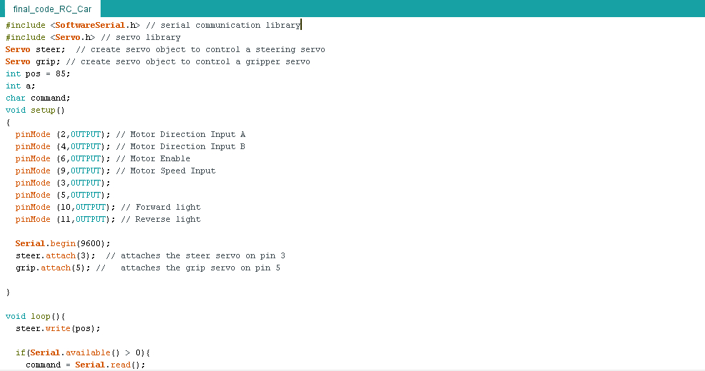
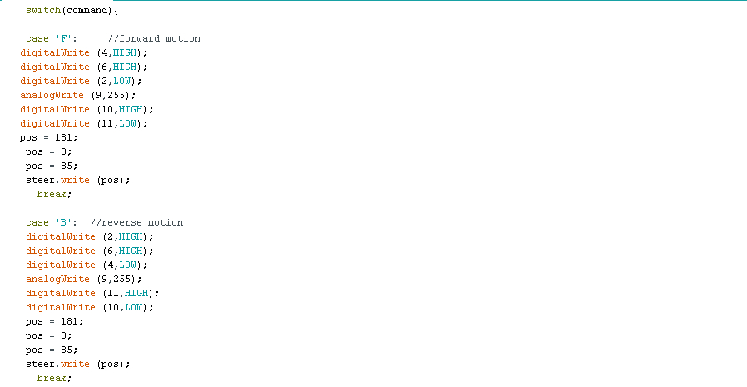
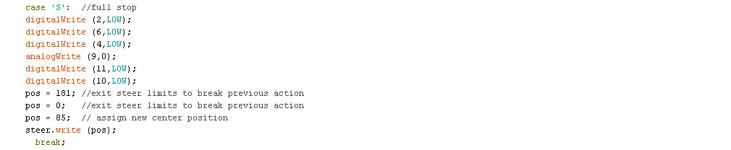

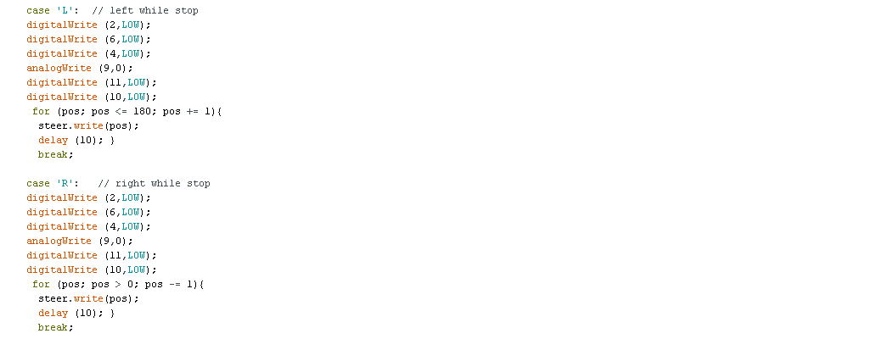
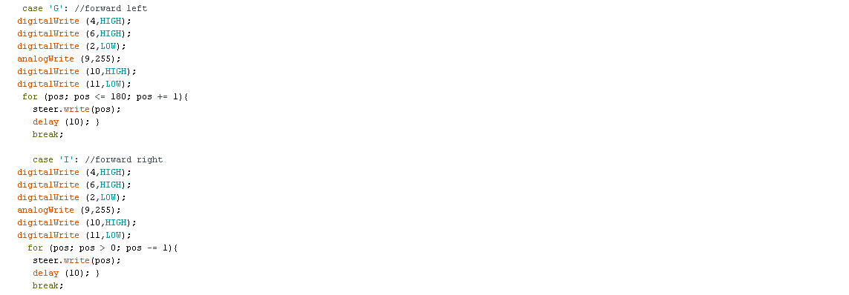
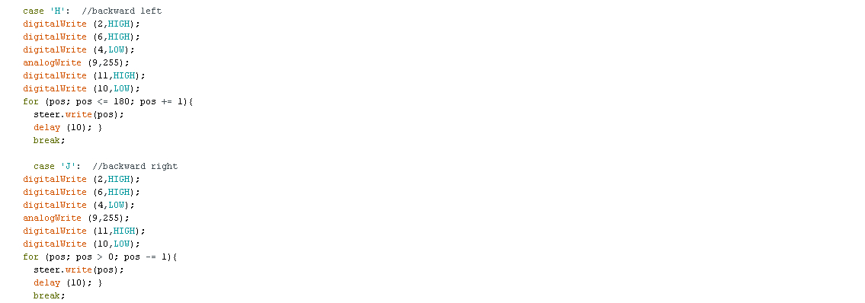
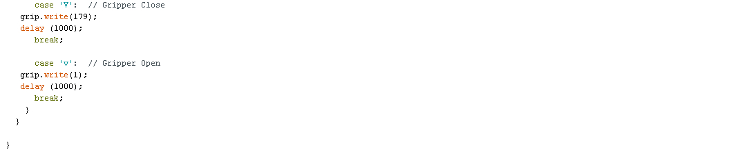

D: (Project Design Calculations – Formulas’ list and full calculation)

Force exerted by servo motor for steering:
$$F=\frac{T}{L}$$

Force required for the car to climb the ramp:
$$Freq=mgcos\left(α\right)×μ+mgsin\left(α\right)$$

Force 2 DC motors can provide:

$$Fm=2×\frac{T}{R}$$
Maximum Speed of the vehicle:

$$Vmax=RPM×Lwh(2×π×R)$$

Torque required to be produced by servo motor to hold the cup:

$$T=W×d$$
Safety factor for the gripper:

$$sf=\frac{Tac}{Thold}$$

Motor speed is 160 RPM. The diameter of chosen wheels is
45 mm. These values will allow our car to achieve a maximum speed of 0,71m/s.
$Vmax=RPMmax×L$(2$×π×R)$
Lwheel = = 0.2673m
Vmax. = 160RPM*0.2673m (per rotation) = 42.77 m/minute ~ 0.71
According to our calculations the approximate weight of the vehicle is around 2.5 kg. The torque produced by the motors is 39.24N*cm (Zhengke Motor, 2020) which will allow us to acquire a force of 34.8 N.
Freq. – force required to climb a ramp
Freq. = Ffr. + Fs. (Force of friction + Force of slip)
$$Freq=mgcos\left(a\right)×n+mgsin\left(a\right)$$
F req.= 2.5kg * 9.81m/s^2 * cos(23°) * 0.7 + 2.5kg * 9.81m/s^2 * sin(23°) = 25.39N
Fm - force provided by motors
$$Fm=2×T/R$$
Fm. = 2 * 39.24 N-cm /2.255cm = 34.80 N
This force is enough for the car to climb a ramp with an angle of 23 degree.
(Note* Actual Torque provided by DC motors, and, as a result, Motor Force is significantly higher than stated in manual)
The steering servo motor will produce a Torque of 4 kg/cm. Considering the weight of the car is 2.5 kg and that most of the weight is concentrated on the Rear Drive. The weight we consider on steering wheels is 0,7kg. The mechanical coupling gives us approximately 4cm of lever.
$F=\frac{T}{L}=4 kg*cm/4 cm=1kg$ (Erjavec, 2002)
Therefore our car will have enough force to steer as F>W.
To hold and transport a coffee cup securely F holding supposed to be greater than a cup weight.
Wcup (with ping-pong balls) ~ 25g * 9.81m/s^2 / 1000 ~ 0.25N
$T=W×d$, (distance from the motor shaft to the gripper contact point)
Thold = 0.25N * 7cm = 1.75 N-cm
Actual T of servo motor = 40.21 N-cm
$$sf=\frac{Tac}{Thold}$$
sf ~ 22 – Great safety factor ensures Cup is held securely even during acceleration and motion at maximum speed.
E: (Project Expenses Table)

Bill of Materials
Component Name | Specifications | Quantity | Part # or  Supplier Code | Manufacturer
Power components
Battery | 12 VDC, 1.3ah | 1 | AJC-D1.3S | AJC® Battery
DC Power Motor | 12 VDC, 160RPM | 2 | ZGB37RG(A6587) | Zhengke Motor
Wheels | 4.255 cm Radius | 4 | - | -
Servo Motor | 4.1 kg-cm Torque | 2 | HS-422 | HITEC RCD USA
Gripper | 4.20” /10.67cm  Wide | 1 | 637096 | Actobotics
Power Switch | SPST | 1 | SWROC-011014 | -
Fuse+holder | 20mm, 2A | 2+1 | MDL-2 | Bussman
Signal Processing
Integrated microcontroller board | ATmega328P  Microcontroller | 1 | A000066 | Arduino
Motor Driver (Shield) | Arduino-compatible | 1 | ARDMD-002507 | Pololu
Ultrasonic Sensor | 40kHz  Frequency,  5V | 1 | HC-SR04 | Adafruit Industries LLC
Bluetooth Module | 20-30m Range,  2.4 kHz Frequency,  5V | 1 | HC-05 | Lafvin  (Made in China)
LED | 20-25 mA, current rate,  1.8V drop | 5 | SLR-56VR3F | Rohm Semiconductor
Resistor | 330 Ohm,  ¼ Watt | 5 | RB-Spa-1509 | Sparkfun Electronics

Cost of the project "RC Car"
Part # | Part Name | Price per unit in CAD | Quantity | Total in CAD
1 | Battery 12 V AJC-D1.3S | N/A | 1 | N/A
2 | DC motor geared 12V ZGB37RG | N/A | 2 | N/A
3 | Motor Driver ARDMD-002507 | 60 | 1 | 60
4 | Microcontroller Arduino Uno | 28 | 1 | 28
5 | Blutooth Module HC-05 | 5 | 1 | 5
6 | Servo motor HS-422 | 18 | 2 | 36
7 | Ultrasonic sensor HC-SR04 | 5 | 1 | 5
8 | LEDs, wires, resistors,etc | 20 | 1 | 20
9 | Wheels | N/A | 4 | N/A
10 | Actobotics Gripper | 16 | 1 | 16
11 | Switch, fuze | 12 | 1 | 12
 | HST (13%) |  |  | 23,66
 |  | Total cost in CAD : | 205,66

F: (Original and Actual Timeline – Gannt Chart)

Original Timeline
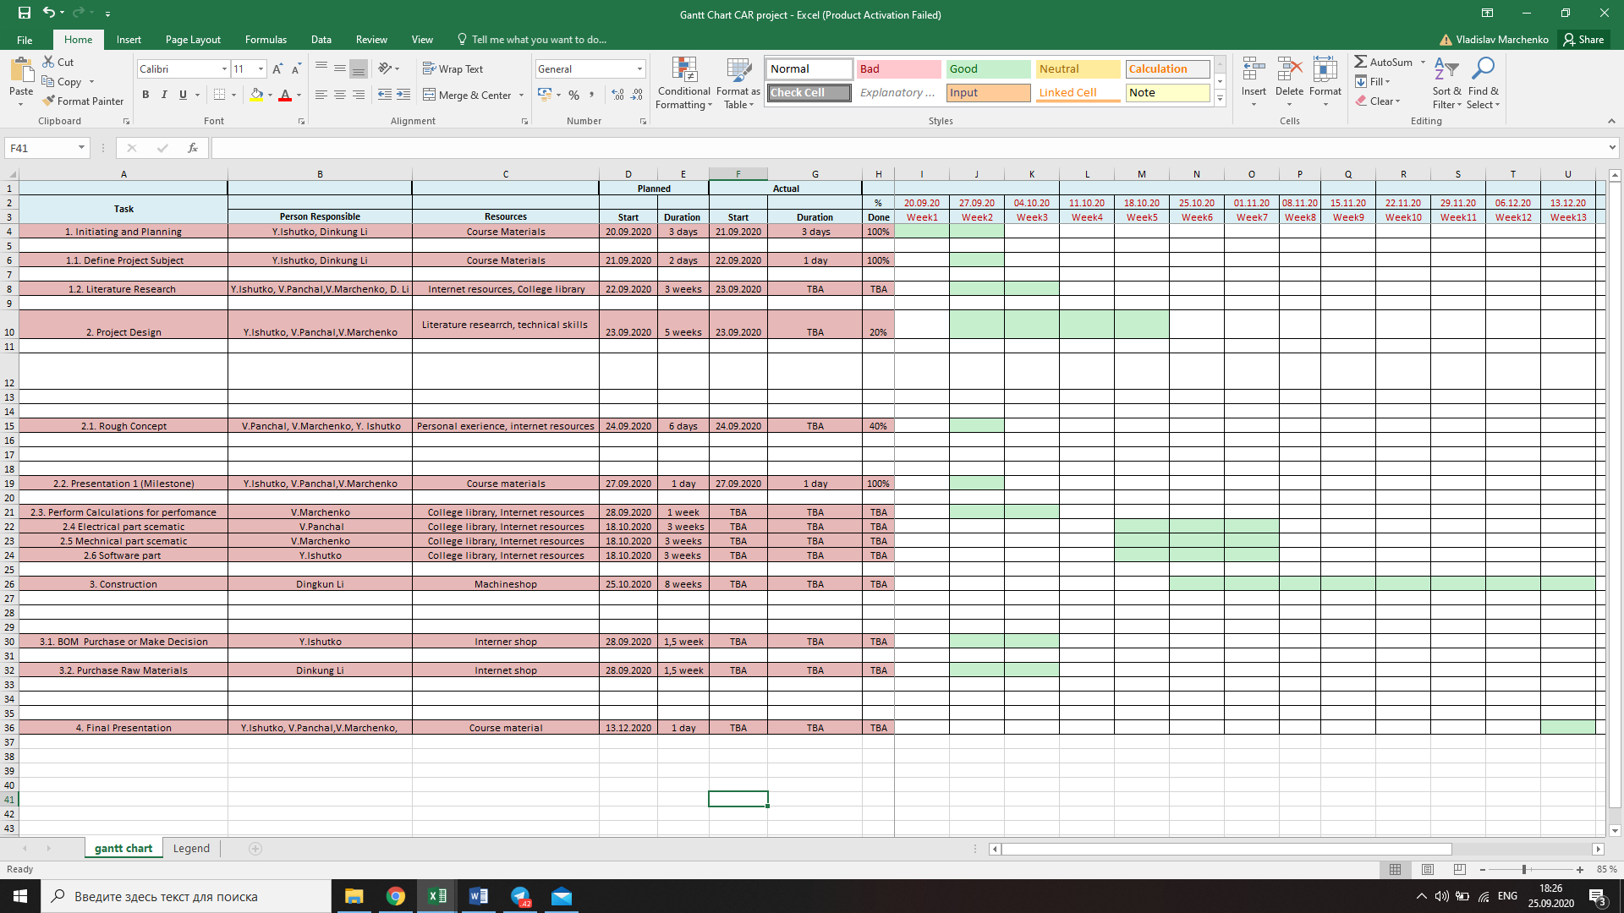
Actual Timeline
